STEPS IN DEPLOYMENT OF ML MODEL IN

WEB APP

1. Deploying the ML model using Streamlit and Heroku , for this I have use pycharm application.

STEPS:

1. First import all the required libraries such as streamlit , pickle etc.

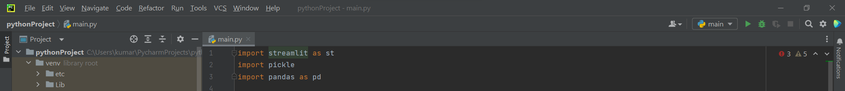

1. If it shows any error , install that lib by using cmd and write ‘pip install streamlit’ .
2. After successful installation , go to your main python program and using pickle command load the pickle file and copy it.
3. Paste that pickle file and dump in pycharm. 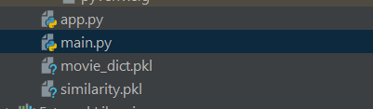
4. Write codes of streamlit according to your need and can take help of streamlit documentation website for better result. 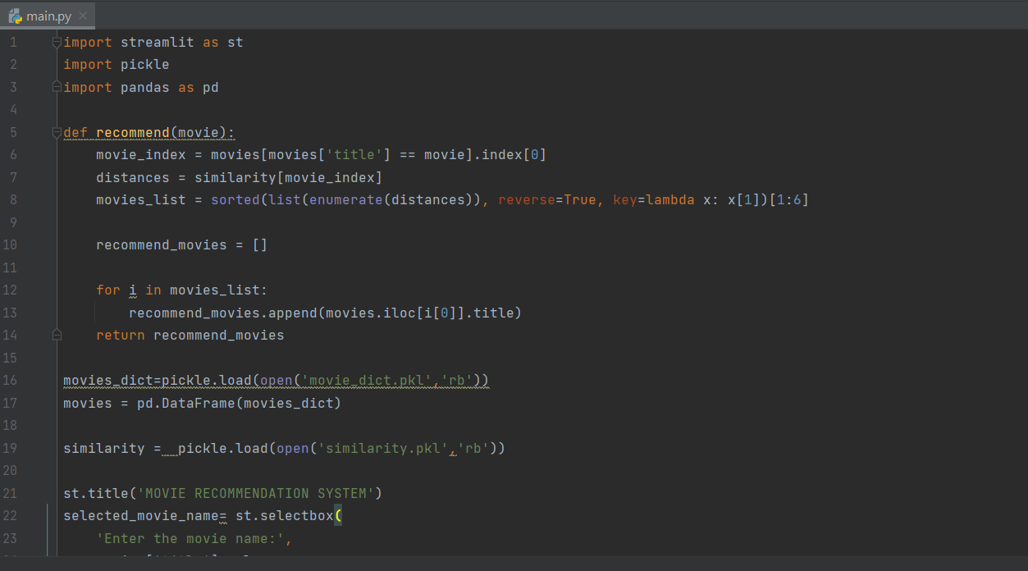
5. Go to cmd and write streamlit run main.py #here main.py is file name
6. Web browser will open . 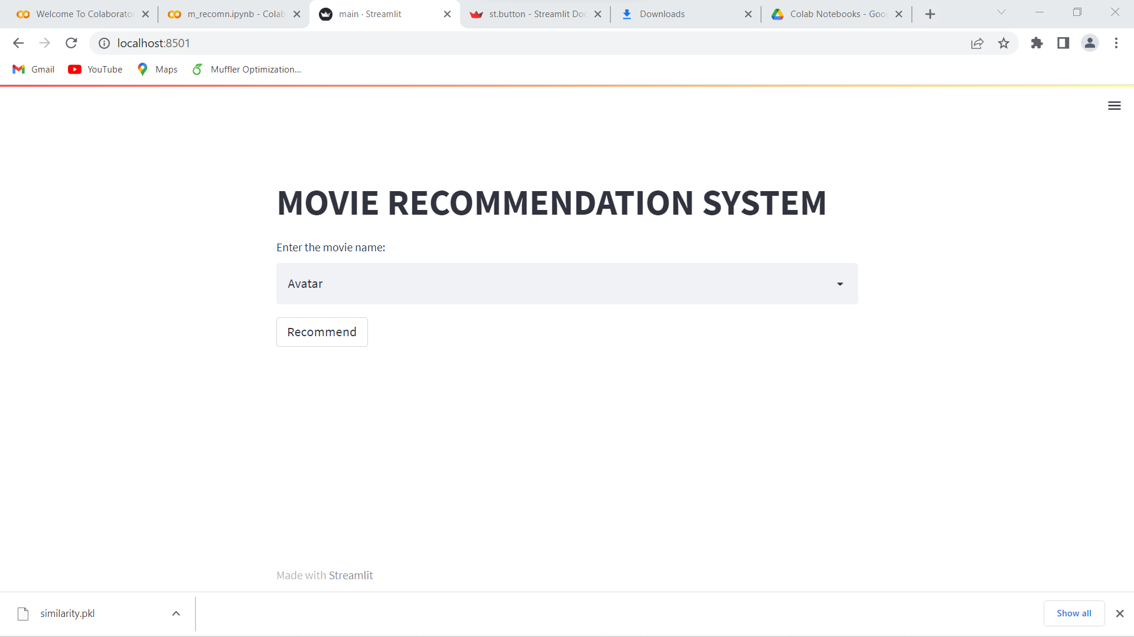

**DEPLOYMENT IN SERVER**

1. Make a file with file name Procfile and write

web: sh setup.sh && streamlit run main.py

1. Make another file with file name setup.sh and write code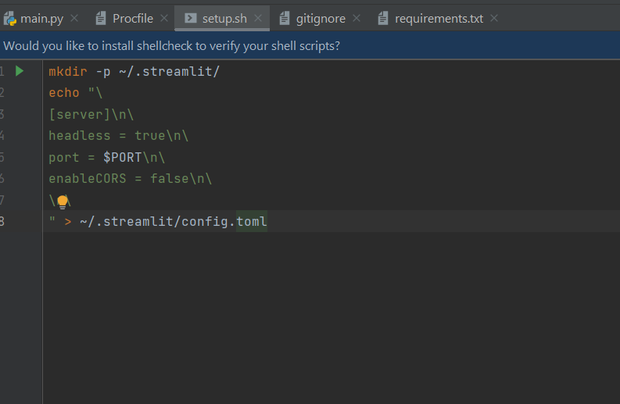
2. Make 3rd file gitignore and write the virtual environment name i.e venv
3. Create requirements.txt file and write streamlit and requests, it will create a file which contain all the lib name which will require. 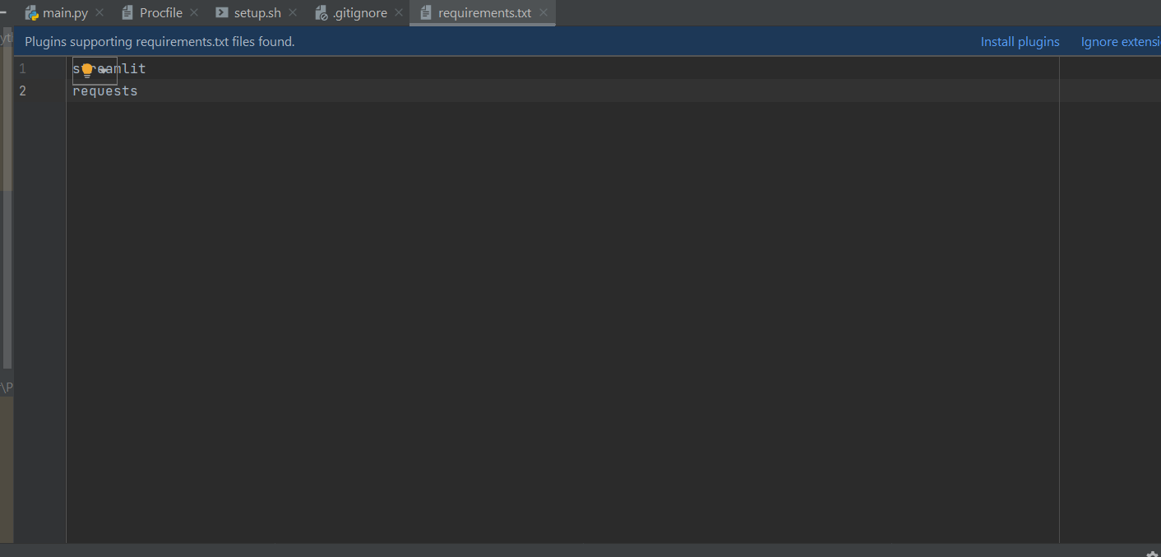
4. After this install Heroku if not installed , go to pycharm cmd and write heroku login you will automatically go to log in page .
5. After login open heroku in browser and create an app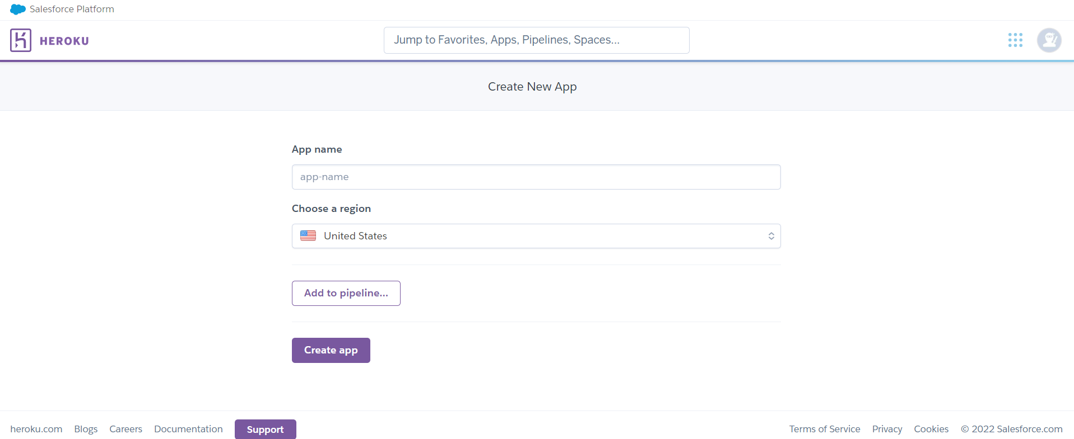
6. Give name to that app ,after that using heroku cli write the command in cmd one by one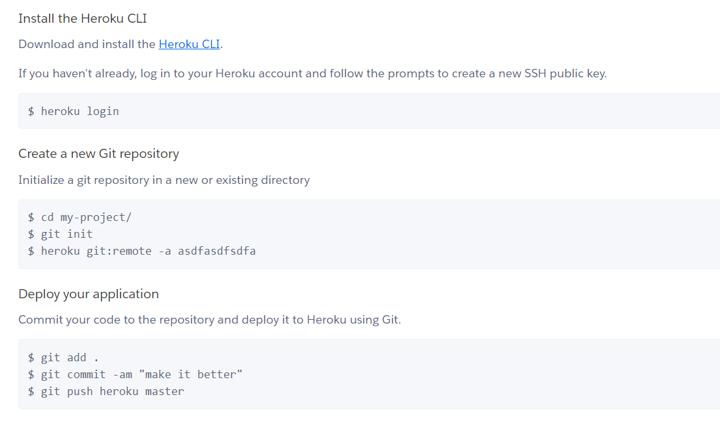
7. After completion of these steps you get the link in cmd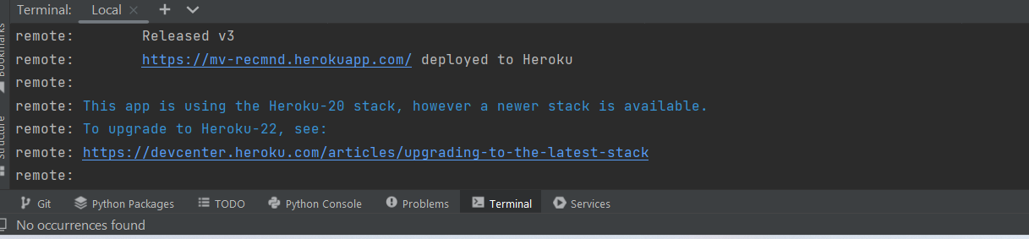
8. Open that link and your model is successfully deployed. 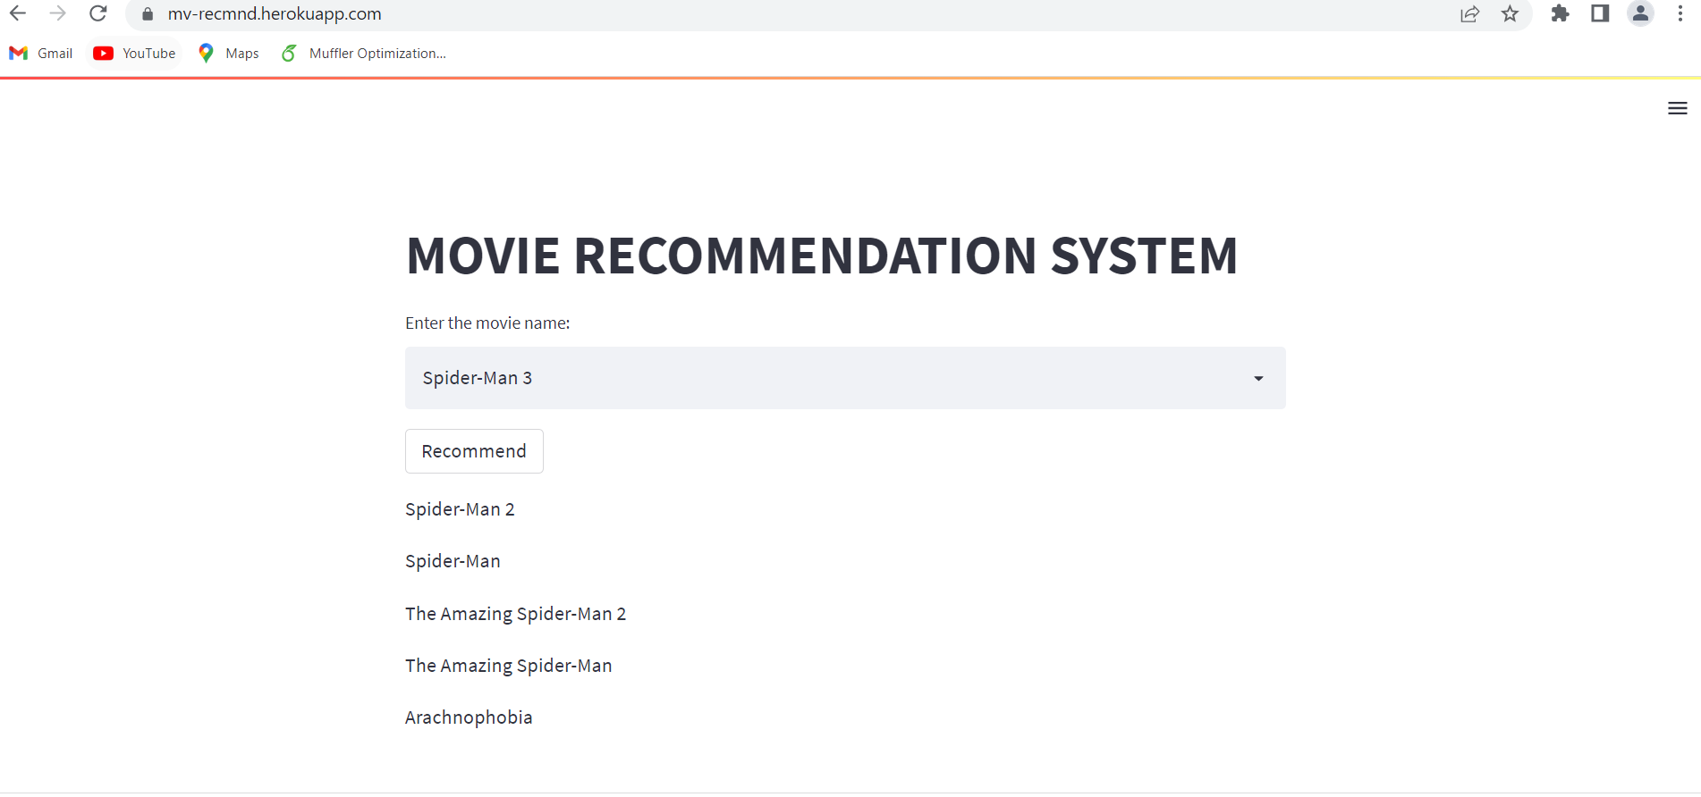

Link : <https://mv-recmnd.herokuapp.com/>